**High St Uniting Church Frankston**

**Waiting in hope and love Isaiah 2:1 – 5**

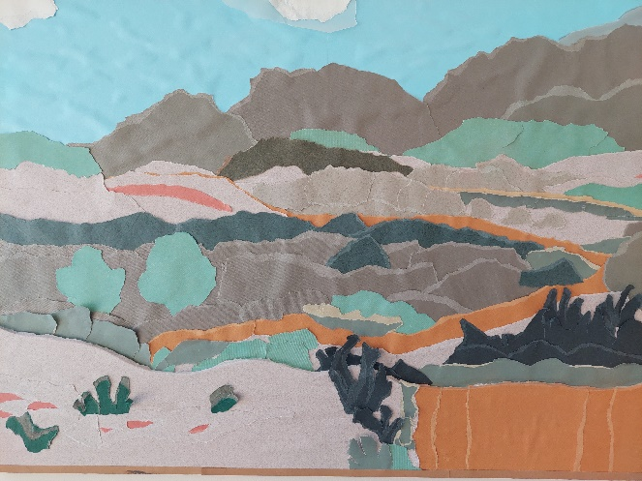

What is it about mountains that makes them so dominate the stories of scripture? Noah, Moses, Elijah, Jesus going up mountains, preaching on mountains, being transfigured on a mountain, departing on a mountain. And it’s not just scripture, mountains and heights figure in so many cultures. The impressive bulk of a mountain, something the Egyptians and the Mayans tried to capture in pyramids. And there is the wonder of vistas and visions that come from being on mountains. There is something deep within us that responds to mountains and high places. Even people who don’t like man-made heights, respond to mountain lookouts. A yearning and wonder that is captured in the story of the tower of Babel; height equates to being close to God. Our Celtic forebears talk of ‘thin places’, places where the dominance of mortal reality thins out and the divine feels close. And mountains are most definitely ‘thin places.’ And the scriptural stories seem to capture this yearning in both directions. Mountains are not just places that people go to feel close to God; they are places where God comes close to people. So, when Isaiah has this vision of the mountain of the Lord’s house being established above all other mountains, there’s something tingling within us. All that awe and wonder in us about mountains, intersects with all the awe and wonder in us about God, and we catch a glimpse of something wonderful ahead of us. And something much richer and deeper behind the Christmas story of the angels greeting to the shepherds – “Peace on earth and goodwill to people”.

The mountain of the Lord’s house is figurative language for the Temple on the highest point in Jerusalem. It’s not quite a mountain, taken literally, but prophetically it is the Temple Mount, Mt Zion, the mountain of the presence of God. And the heart of the Isaiah passage we heard today – and you will find its twin in Micah, reflecting a nationwide urge for peace – is the vision of the dominance of the ‘mountain of God’ over all other mountains. When this text was first written it was common for worship of other gods to take place on mountains and high places. We see it mentioned in many places in the history of Israel in the books of Kings and their parallel in Chronicles. So, we aren’t talking about a literal raising of Jerusalem to be higher than other mountains, but a prophetic vision of the worship of the one true God to take precedence over all other worship, and in that one worship is the basis of peace amongst the nations.

Isaiah’s universalist vision may have been a bit confronting for the first readers in Judah who were convinced that God was the God of Israel. But it was, and is, a picture of attraction and welcome, in the face of empires dominating and trying to bring people together through violence and conquering. A vision that God was not interested in bringing retribution and judgement on the enemies of Israel – including the Assyrians threatening Jerusalem at the time – but had a future in mind that gathered everyone in peace and joy. And that universalist vision may be challenging today, in this multi-faith, multi-cultural society, but we are certainly not taking up the attraction and welcome message at the heart of Isaiah’s vision if we get offended by ‘happy holidays’, forgetting that we are not the only religion celebrating holy days at this time of the year, or take up a Scrooge like attitude to all the commercialisation and mythologising of the secular Christmas. We are called to display to the world the grace and love of God, like the mountain lifted up, and to welcome all to worship.

This vision of the mountain of the Lord’s house, with nations streaming to hear from God and have their quarrels judged, comes to us as the beginning of our worship journey of Advent. We are not just heading towards the great celebration of Emmanuel – God with us – we are heading towards the mountain of the Lord’s presence. We are not just counting off the weeks before Christmas, we are walking the path up the mountain to join with people all over the world in commemorating the child born for us.

The great story of Jesus transfiguration on the mountain, and the reluctance of the disciples to leave there and go back to their lives gives us the metaphor of ‘a mountain top experience’. We talk about it after every camp, conference, or convention. And here we have a reading leading us to look towards Christmas in a more intentional way. A mountain top experience as we collectively – here and all around the world – gather in the presence of God. A mountain top experience that many are looking forward to. It’s not just our children that think Christmas is the greatest time of the year, there are many who want Christmas to come now and not stop! But the Advent season is about anticipation and waiting. In following the visions and words of Isaiah it’s about anticipating and waiting for the prophecies of the wonder, the union, and the peace that come with the reality of God with us.

Now, some of you may be a bit tired after all that has happened in the last three years and don’t like the idea of a journey to Advent, particularly one that involves climbing a mountain! But that, of course, is all just metaphor. Climbing this mountain simply means each week taking on a new idea, or insight, or understanding, that together, over the four weeks, helps you to see Christmas with a new appreciation, or deeper meaning, or fresh eyes. This week take that wonderful vision of God with us being the source of peace as added depth to the angelic message to the shepherds, it’s not just a divine greeting, the promised peace reflects a yearning of God over hundreds of years. Or take up the idea that Jesus himself is the new mountain of the Lord’s house, established above all the other mountains. The one who calls and gathers the nations of the world in worship of God the Father of all.

May Isaiah’s vision of the nations of the world gathered before God in peace and mutual support fuel your hope and waiting as we all look to that wonderful kingdom of the doing of God’s will coming real in our world.